NMH Scrub SOP
In the file attached – please have your team members pull account (column B)
For all accounts in RED– please have your team flip that account number to – Rejected Referral – Already insured, and that’s it 😊
For all accounts in BLUE– please have your team flip that account number to – Pending Approval, then please Add New Application – application name is – Medicaid ACE – and link those accounts that you just flipped to pending approval to that application.

FAQs
1 . When adding application for Medicaid ACE, what details should we provide for the following(please see attached photo below). We cannot proceed without the following details.
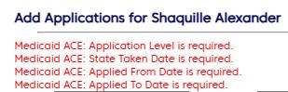
- put all dates 'today'

2. What if the accounts in BLUE is already on billing list , how can we switch it back to pending approval?
- if the blue account is already on billing list then no worries, please skip

3. What should we choose for agency?
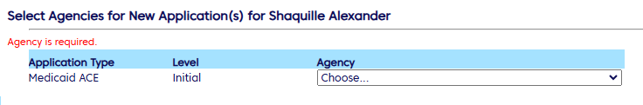
- select “180” on the options
3. If my name is not listed under HCR , who should I choose to proceed?
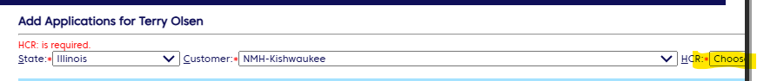
- Please choose Norma Arellano as the default HCR

